**ZUNHEBOTO GOVT. COLLEGE**

CULTURAL COMMITTEE REPORT

-*by Cultural Committee*

1.Pre-Ahuna Celebration cum Live Concert was organised on 2nd November, 2022 with K. Caroline Chishi, Vice Principal, Govt.Hr. Sec. School, Zunheboto as the Special Guest and Dr. Husukha Yepthomi, Working President, NPF Zunheboto as the Guest Speaker. Indigenous activities like bamboo climbing, tug of war and fats eating competition were the highlights of the event.

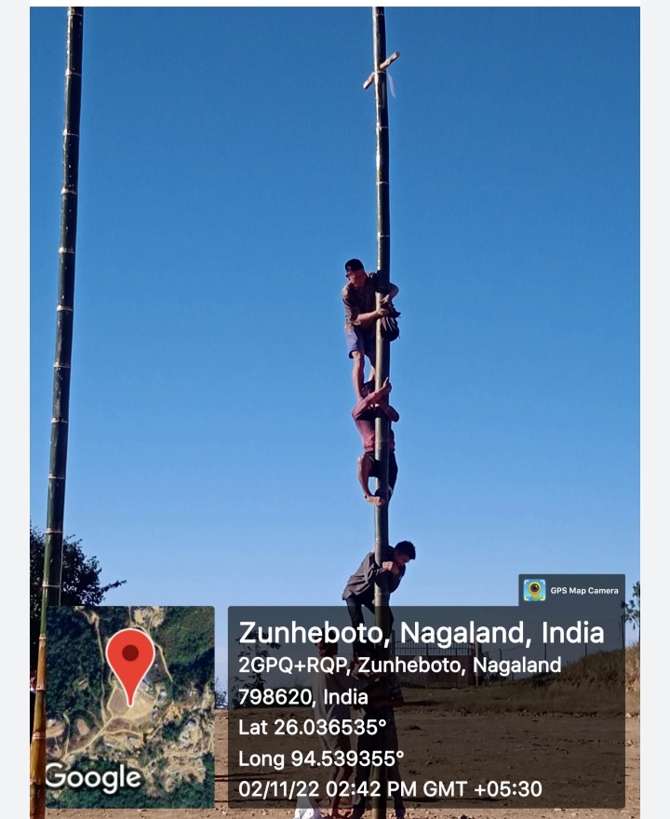

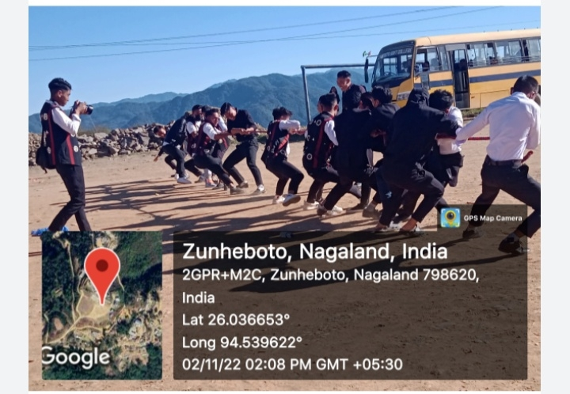

2.On account of World Heritage Day, 2023, the Cultural Committee Zunheboto Government College, organized a ‘Poster Competition’, on the 18th of April, 2023 with the motive of enlightening the students about the importance of appreciating the rich cultural heritage of the Nagas, and the need to preserve the same. The competition was made open to students of all semesters, the theme being; “*Preserving Our Cultural Identity*”.

The selected Posters:

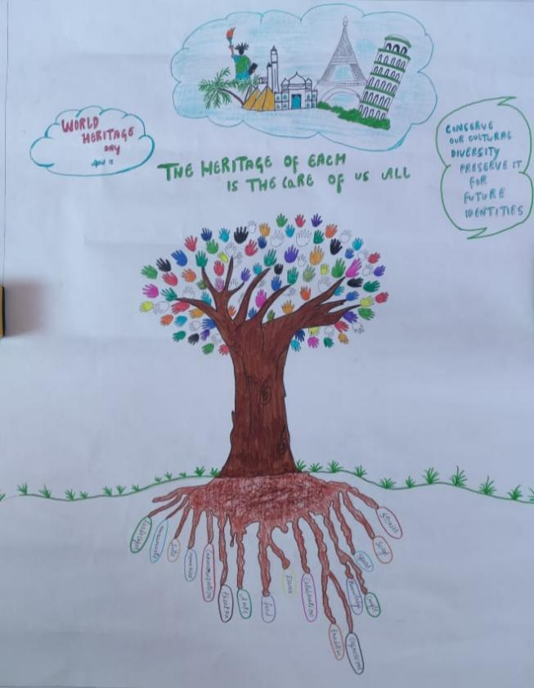

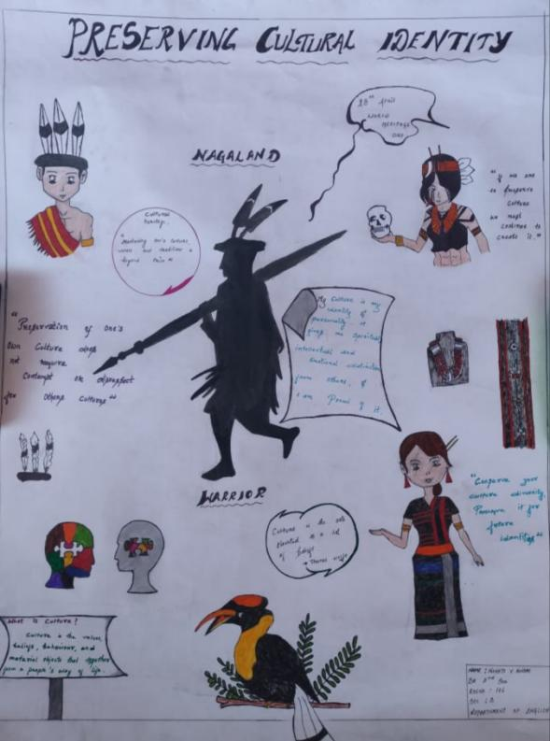

**Two winners were adjudged as winners of the competition:**

**1.Hinato Kiba, 6th semester, Geography Department**

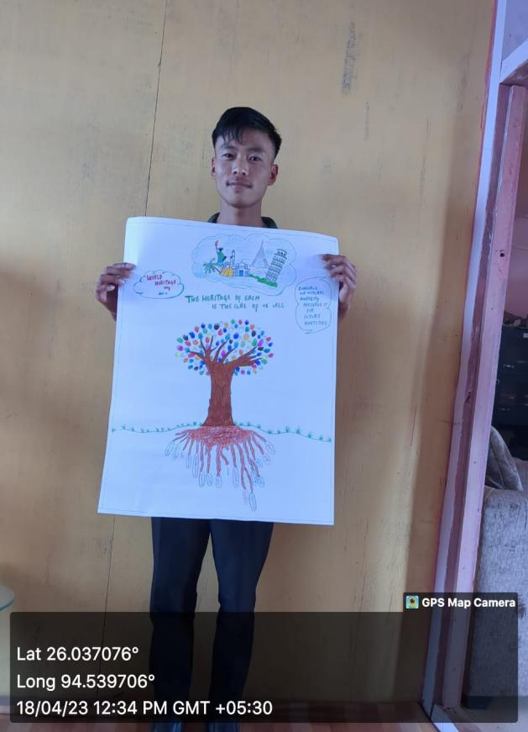

2. **Ninoti Awomi, 2nd semester, English Department.**

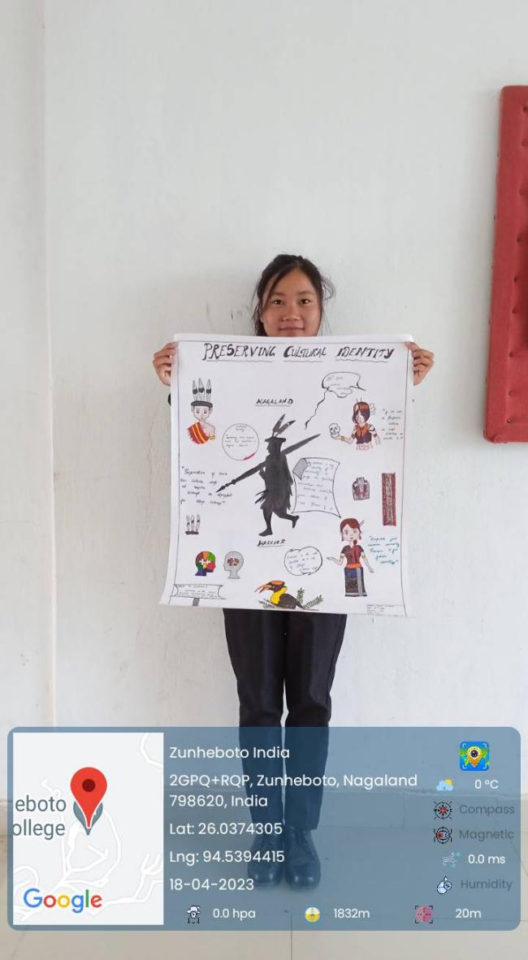

The winners were awarded cash prizes of rupees 1000/- each, and encouraged by the committee and the teachers, to continue to hone their talents. The Cultural Committee looks forward to organize more varied activities/ programs that would not only educate the students about the importance and beauty of Cultural Heritage but also help them discover and enhance their talents and creative thinking.