**NSS REPORT (2022-23)**

1. The number of NSS volunteers was 150 during the year 2022-23.
2. The Orientation programme for the volunteers was conducted on 2nd August,2023 in the conference hall.The volunteers were highlighted about the importance of NSS, activities conducted under the flagship programmes. At the end of the programme the volunteers took a pledge to serve vigorously and with full dedication.
3. Miss.Hulika Zhimo, PO NSS attended the orientation programme at IIE ,Guwahati from 12th-17th August,2022.

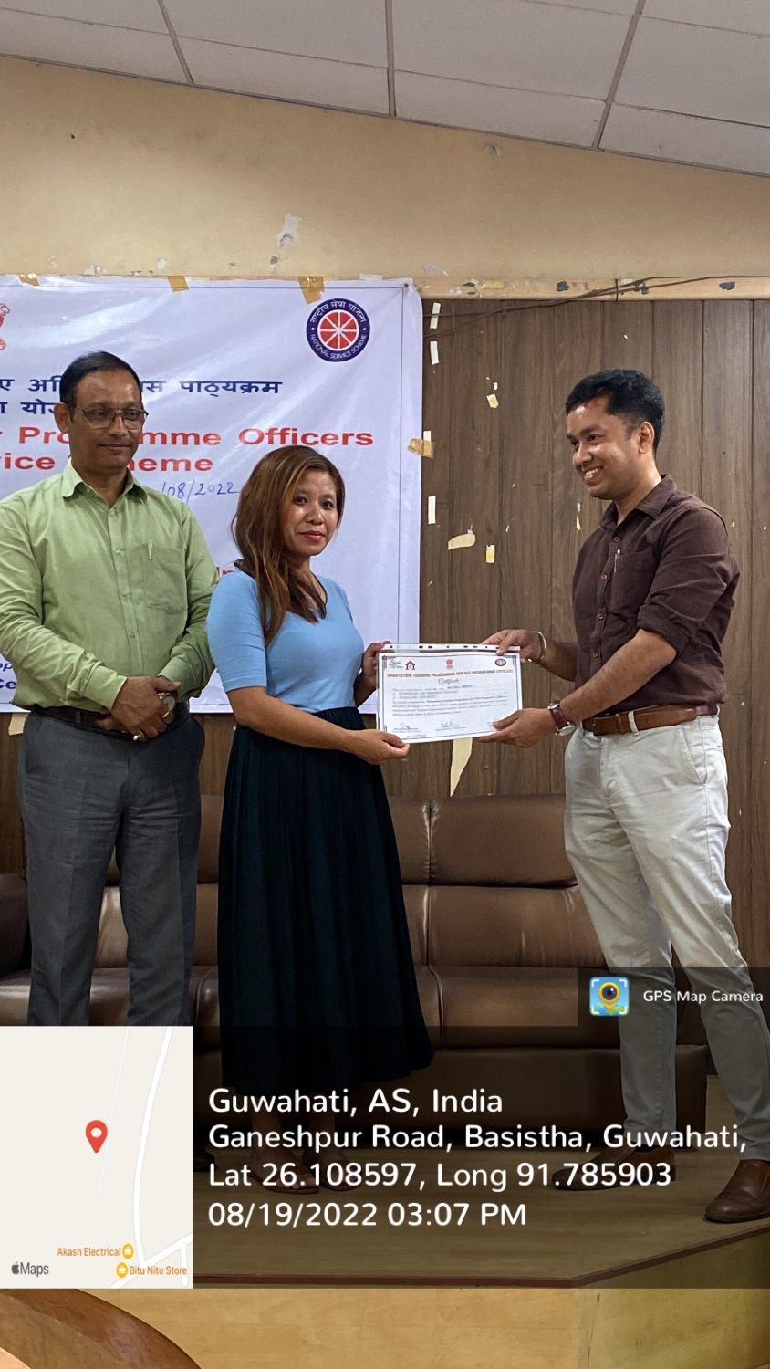

1. On occasion of Independence Day,the NSS cell visited the District jail and interacted with the inmates.
2. The NSS ZGC attended the National Integretion Youth Camp at Mahabodhi College,Nalanda,Bihar. The Volunteers presented a men folk dance to embark our rich culture heritage.

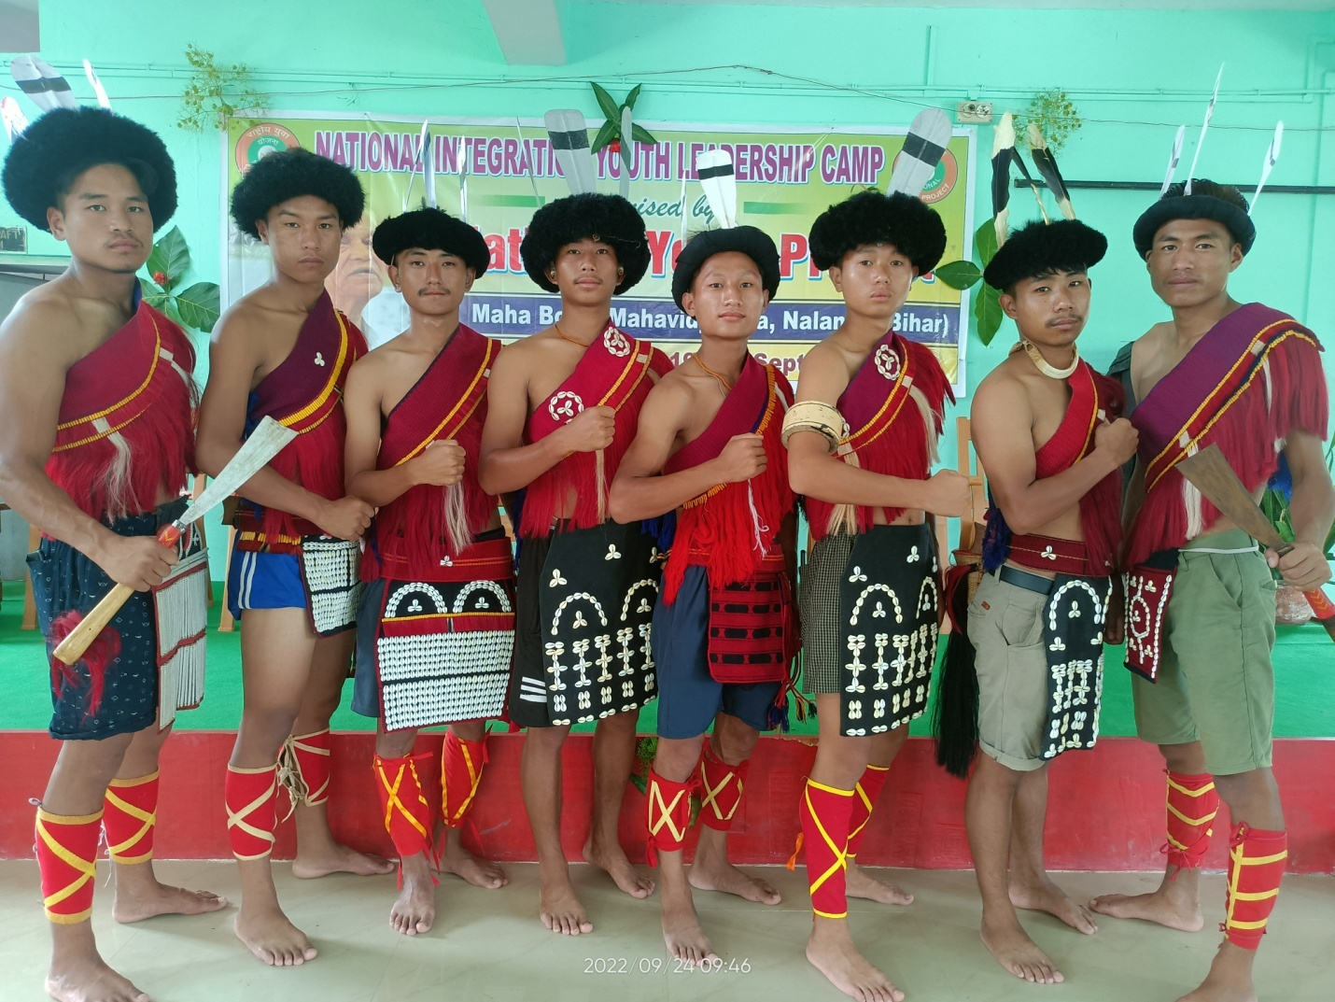

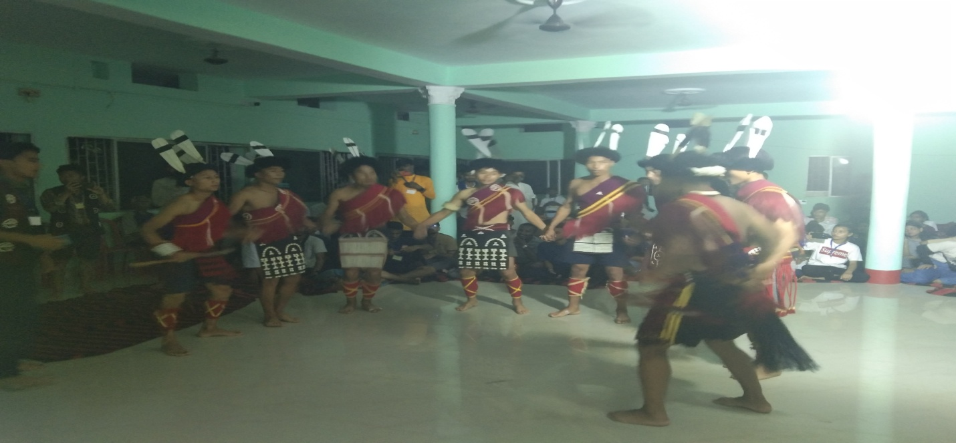

1. Miss Hulika zhimo on 16th March,2023 attended a special training on youth survey at Dr.Ambedkar International Centre,Delhi conducted by the Ministry of Youth Affairs and Sports.
2. The NSS special camp was conducted from 23rd -26th March,2023 at Baihmo Village (NSS adopted village) under the theme “not me but you.” During the special camp the volunteers conducted survey of “ youth not in formal education nor employed” as per the directives of Ministry of Youth Affairs and Sports.Besides,the volunteers also carried our SWACH BHARAT activities,visited old age homes and the primary school.

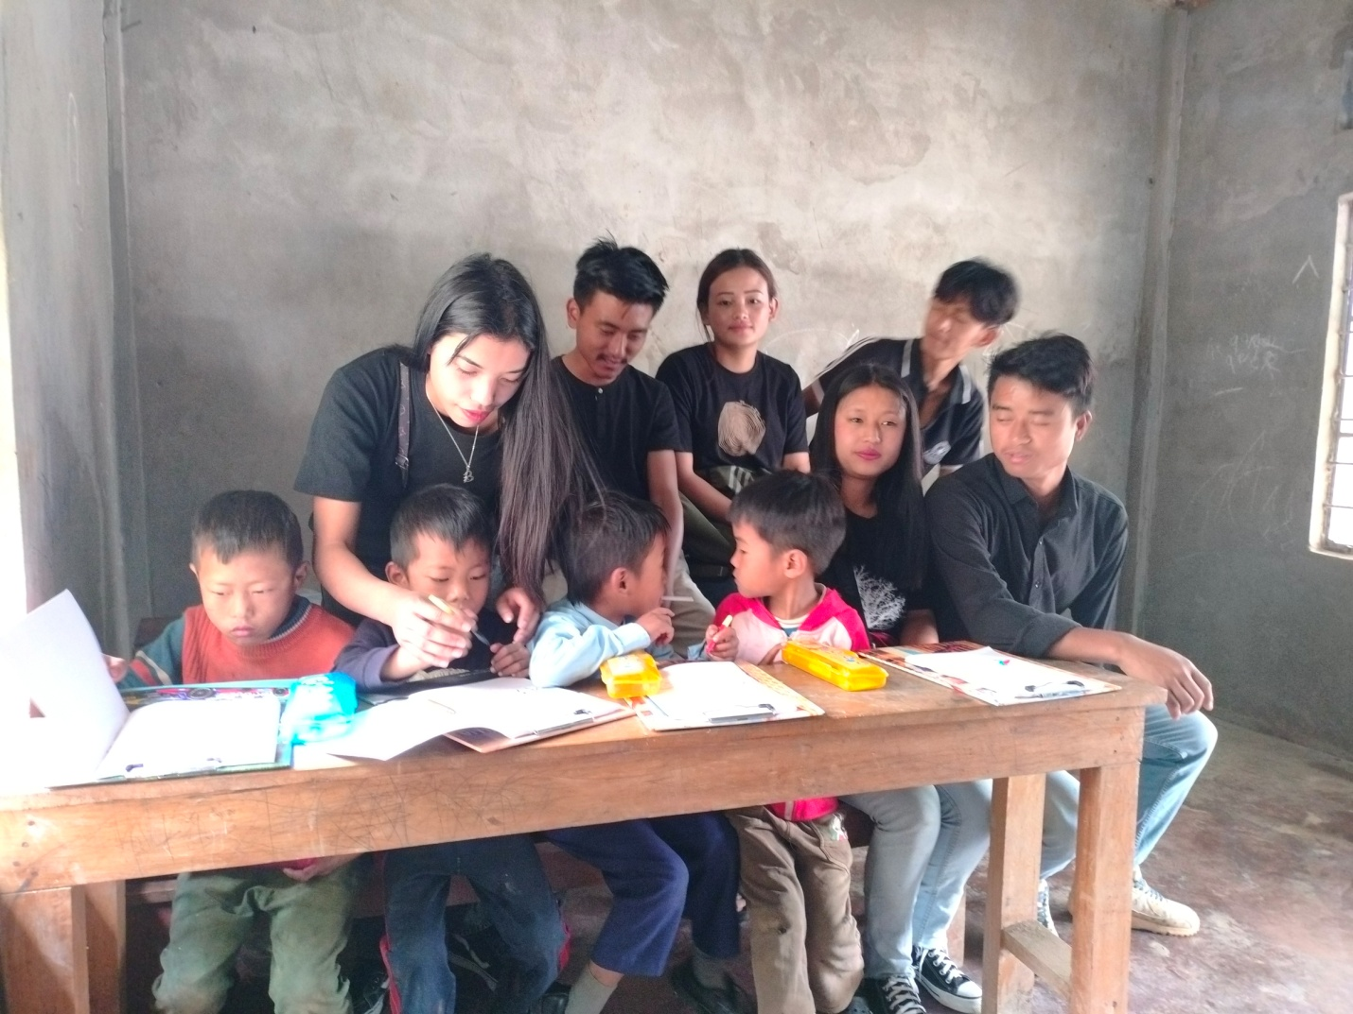

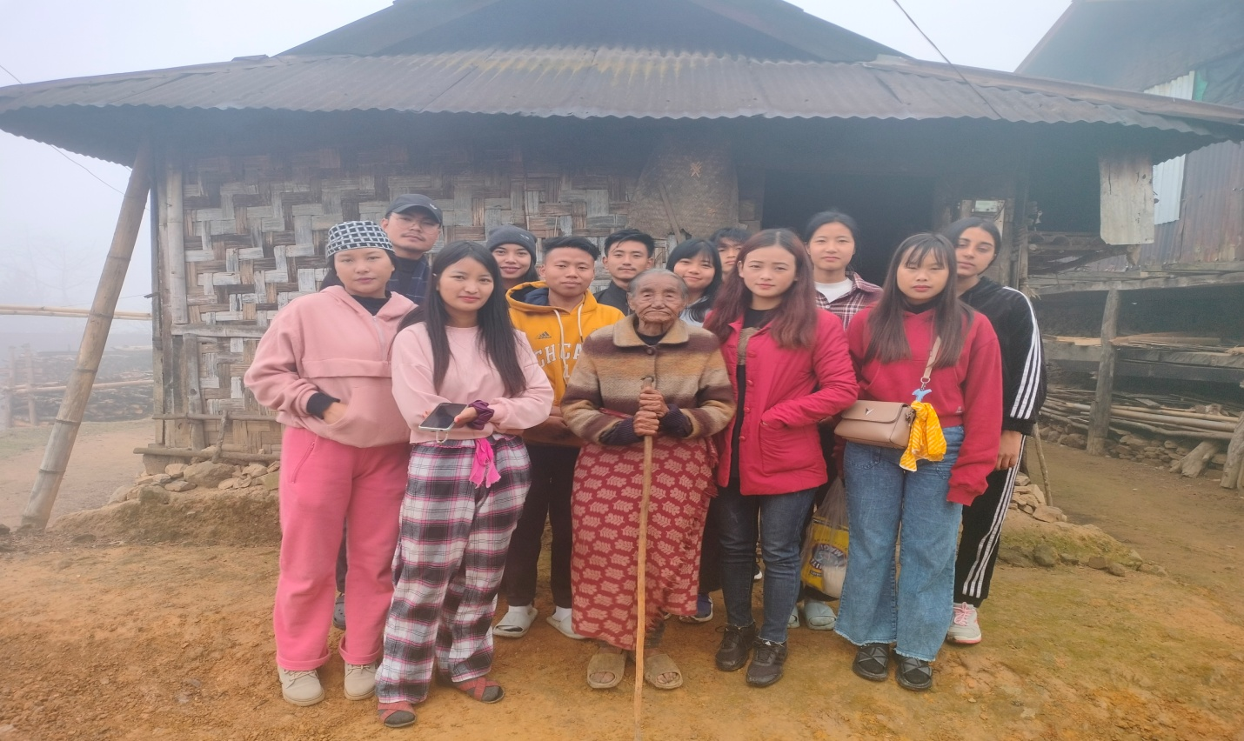

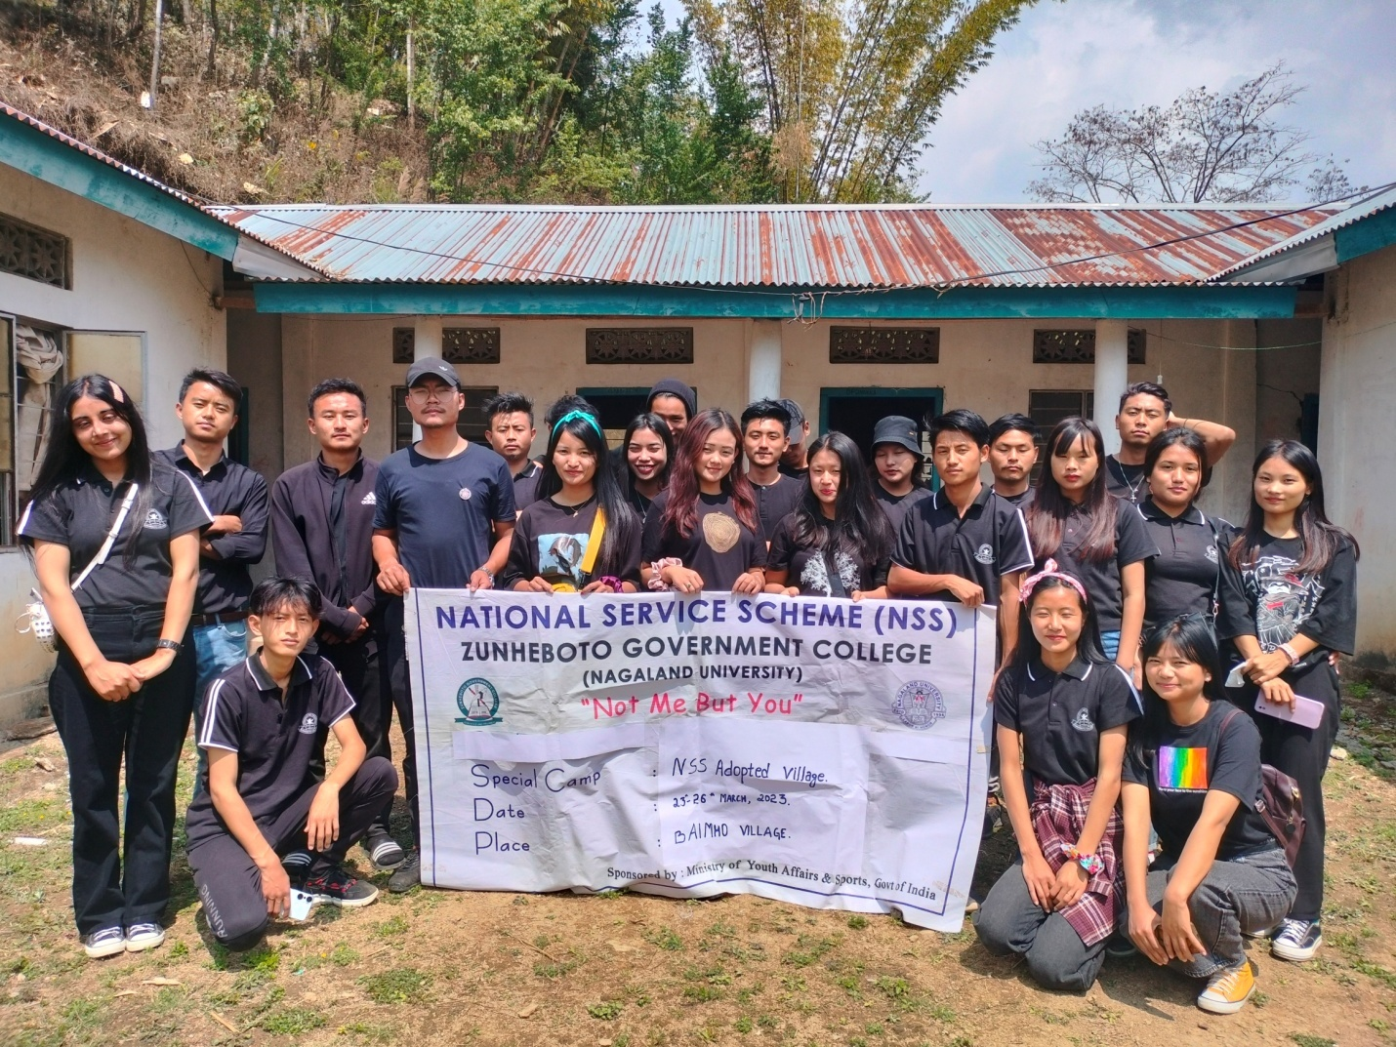

1. Atleast 50 volunteers were able to donate blood during this session.The NSS volunteers also took active part in the other regular activities.

Submitted by :

Hulika Zhimo

NSS PO

Zunheboto Govt. College